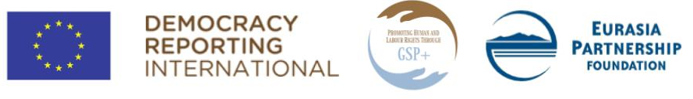

Training for regional CSOs on reporting to UN treaty bodies

Application form for regional human rights activists
Your full name:
E-mail:
Address:
Phone:
Have you ever worked in the areas of right to adequate standard of living, ethnic/religious minority children’s rights, right to physical and mental health and/or labour rights? Please, provide details. (up to 200 words)
What other human rights related work have you done? (up to 100 words)
Have your ever participated in preparation of alternative report(s) to UN human rights bodies? Please provide details. (up to 100 words)
Human rights issues you are concerned about: (up to 100 words)
What are the reasons you want to participate in the two-day training? (up to 150 words)
Are you committed to participate in the training the both days?
Please, note that some of the participants of the training will be expected to join the working groups of regional NGOs, operating in Shirak, Armavir, Gegharkunik or Syunik (depending on the region the participant resides in). These working groups will be tasked with drafting the alternative reports to UN treaty bodies under guidance of appointed coaches. Please, let us know whether you will be available to join one of those working groups:
Please, kindly indicate, if you have a disability and/or any special (including dietary) requirements that may require accommodation (this information will in no way affect your chances of being selected):

