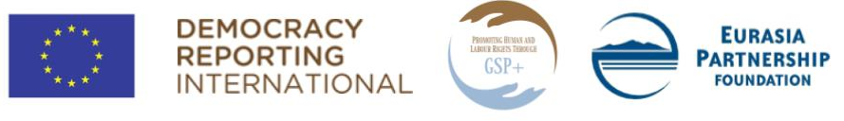

Training for regional CSOs on reporting to UN treaty bodies

Application form for regional NGO representatives
Your full name:
E-mail:
Name of the NGO you represent:
Region, address of the NGO:
Phone (office/mobile):
Website (if any):
When was the NGO established?
What is the mission of the NGO?
(up to 50 words)
What kind of activities does the NGO implement? (up to 100 words)
What is your position and responsibilities within the NGO?
(up to 100 words)
Who are the beneficiaries of the NGO? (up to 50 words)
Have you and the NGO you represent ever worked in the areas of right to adequate standard of living, ethnic/religious minority children’s rights, right to physical and mental health and/or labour rights? Please, provide details: (up to 200 words)
Has your NGO ever submitted alternative report(s) to UN human rights bodies? Please, provide details: (up to 100 words)
Human rights issues your NGO is concerned about: (up to 100 words)
What are the reasons you want to participate in the two-day training? (up to 150 words)
Are you committed to participate in the training the both days?
Please, note that some of the participants of the training will be encouraged to join the working groups of regional NGOs, operating in Shirak, Armavir, Gegharkunik or Syunik (depending on the region the participant resides in). These working groups will be tasked with drafting the alternative reports to UN treaty bodies under guidance of appointed coaches. Please, let us know whether you will be available to join one of those working groups:
Please, kindly indicate, if you have a disability and/or any special (including dietary) requirements that may require accommodation (this information will in no way affect your chances of being selected):

